LABORATUAR ÇALIŞMASI
1-a
Kod:
**Soru1a
.MODEL MOSN NMOS LEVEL=2 LD=0.15U TOX=200.0E-10
+ NSUB=5.36726E+15 VTO=0.743469 KP=8.00059E-05 GAMMA=0.543
+ PHI=0.6 U0=655.881 UEXP=0.157282 UCRIT=31443.8
+ DELTA=2.39824 VMAX=55260.9 XJ=0.25U LAMBDA=0.0367072
+ NFS=1E+12 NEFF=1.001 NSS=1E+11 TPG=1.0 RSH=70.00
+ CGDO=4.3E-10 CGSO=4.3E-10 CJ=0.0003 MJ=0.6585
+ CJSW=8.0E-10 MJSW=0.2402 PB=0.58
.MODEL MOSP PMOS LEVEL=2 LD=0.15U TOX=200.0E-10
+ NSUB=4.3318E+15 VTO=-0.738861 KP=2.70E-05 GAMMA=0.58
+ PHI=0.6 U0=261.977 UEXP=0.323932 UCRIT=65719.8
+ DELTA=1.79192 VMAX=25694 XJ=0.25U LAMBDA=0.0612279
+ NFS=1E+12 NEFF=1.001 NSS=1E+11 TPG=-1.0 RSH=120.6
+ CGDO=4.3E-10 CGSO=4.3E-10 CJ=0.0005 MJ=0.5052
+ CJSW=1.349E-10 MJSW=0.2417 PB=0.64
VDD 3 0 DC 3.1
VIN 1 0 PULSE(0 3.1 0 1ns 1ns 5ns 10ns)
M1 2 1 0 0 MOSN W=1.8u L=1.2u NRS=0.333 NRD=0.333
+ AD=6.5p PD=9.0u AS=6.5p PS=9.0u
R1 3 2 100K
C1 2 0 1F
.CONTROL
DC VIN 0 3.1 0.1
PLOT V(2) VS V(1)
.ENDC
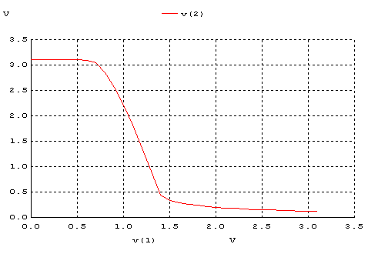

1-b
Kod:
**Soru1b
.MODEL MOSN NMOS LEVEL=2 LD=0.15U TOX=200.0E-10
+ NSUB=5.36726E+15 VTO=0.743469 KP=8.00059E-05 GAMMA=0.543
+ PHI=0.6 U0=655.881 UEXP=0.157282 UCRIT=31443.8
+ DELTA=2.39824 VMAX=55260.9 XJ=0.25U LAMBDA=0.0367072
+ NFS=1E+12 NEFF=1.001 NSS=1E+11 TPG=1.0 RSH=70.00
+ CGDO=4.3E-10 CGSO=4.3E-10 CJ=0.0003 MJ=0.6585
+ CJSW=8.0E-10 MJSW=0.2402 PB=0.58
.MODEL MOSP PMOS LEVEL=2 LD=0.15U TOX=200.0E-10
+ NSUB=4.3318E+15 VTO=-0.738861 KP=2.70E-05 GAMMA=0.58
+ PHI=0.6 U0=261.977 UEXP=0.323932 UCRIT=65719.8
+ DELTA=1.79192 VMAX=25694 XJ=0.25U LAMBDA=0.0612279
+ NFS=1E+12 NEFF=1.001 NSS=1E+11 TPG=-1.0 RSH=120.6
+ CGDO=4.3E-10 CGSO=4.3E-10 CJ=0.0005 MJ=0.5052
+ CJSW=1.349E-10 MJSW=0.2417 PB=0.64
VDD 3 0 DC 3.1
VIN 1 0 PULSE(0 3.1 0 1ns 1ns 5ns 10ns)
M1 2 1 0 0 MOSN W=1.8u L=1.2u NRS=0.333 NRD=0.333
+ AD=6.5p PD=9.0u AS=6.5p PS=9.0u
M1 2 0 3 3 MOSP W=1.8u L=1.2u NRS=0.333 NRD=0.333
+ AD=6.5p PD=9.0u AS=6.5p PS=9.0u
C1 2 0 1F
.CONTROL
DC VIN 0 3.1 0.1
PLOT V(2) VS V(1)
.ENDC
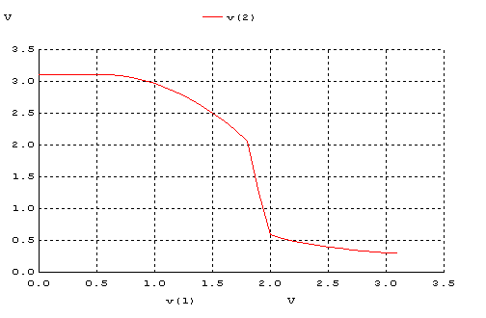

1-c
Kod:
**Soru1c
.MODEL MOSN NMOS LEVEL=2 LD=0.15U TOX=200.0E-10
+ NSUB=5.36726E+15 VTO=0.743469 KP=8.00059E-05 GAMMA=0.543
+ PHI=0.6 U0=655.881 UEXP=0.157282 UCRIT=31443.8
+ DELTA=2.39824 VMAX=55260.9 XJ=0.25U LAMBDA=0.0367072
+ NFS=1E+12 NEFF=1.001 NSS=1E+11 TPG=1.0 RSH=70.00
+ CGDO=4.3E-10 CGSO=4.3E-10 CJ=0.0003 MJ=0.6585
+ CJSW=8.0E-10 MJSW=0.2402 PB=0.58
.MODEL MOSP PMOS LEVEL=2 LD=0.15U TOX=200.0E-10
+ NSUB=4.3318E+15 VTO=-0.738861 KP=2.70E-05 GAMMA=0.58
+ PHI=0.6 U0=261.977 UEXP=0.323932 UCRIT=65719.8
+ DELTA=1.79192 VMAX=25694 XJ=0.25U LAMBDA=0.0612279
+ NFS=1E+12 NEFF=1.001 NSS=1E+11 TPG=-1.0 RSH=120.6
+ CGDO=4.3E-10 CGSO=4.3E-10 CJ=0.0005 MJ=0.5052
+ CJSW=1.349E-10 MJSW=0.2417 PB=0.64
*M1 D G S B MOSP W=1.8u L=1.2u NRS=0.333 NRD=0.333
*+ AD=6.5p PD=9.0u AS=6.5p PS=9.0u
VDD 3 0 DC 3.1
VIN 1 0 PULSE(0 3.1 0 1ns 1ns 5ns 10ns)
M1 2 1 3 3 MOSP W=1.8u L=1.2u NRS=0.333 NRD=0.333
+ AD=6.5p PD=9.0u AS=6.5p PS=9.0u
R1 2 0 100K
C1 2 0 1F
.CONTROL
DC VIN 0 3.1 0.1
PLOT V(2) VS V(1)
.ENDC
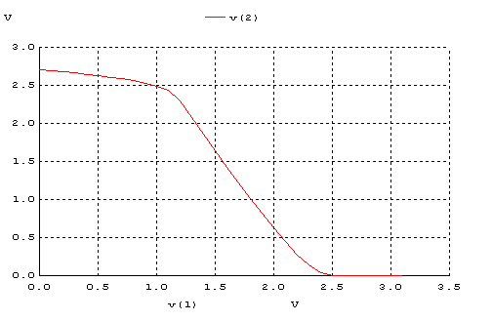
1-d
Kod:
**Soru1d
.MODEL MOSN NMOS LEVEL=2 LD=0.15U TOX=200.0E-10
+ NSUB=5.36726E+15 VTO=0.743469 KP=8.00059E-05 GAMMA=0.543
+ PHI=0.6 U0=655.881 UEXP=0.157282 UCRIT=31443.8
+ DELTA=2.39824 VMAX=55260.9 XJ=0.25U LAMBDA=0.0367072
+ NFS=1E+12 NEFF=1.001 NSS=1E+11 TPG=1.0 RSH=70.00
+ CGDO=4.3E-10 CGSO=4.3E-10 CJ=0.0003 MJ=0.6585
+ CJSW=8.0E-10 MJSW=0.2402 PB=0.58
.MODEL MOSP PMOS LEVEL=2 LD=0.15U TOX=200.0E-10
+ NSUB=4.3318E+15 VTO=-0.738861 KP=2.70E-05 GAMMA=0.58
+ PHI=0.6 U0=261.977 UEXP=0.323932 UCRIT=65719.8
+ DELTA=1.79192 VMAX=25694 XJ=0.25U LAMBDA=0.0612279
+ NFS=1E+12 NEFF=1.001 NSS=1E+11 TPG=-1.0 RSH=120.6
+ CGDO=4.3E-10 CGSO=4.3E-10 CJ=0.0005 MJ=0.5052
+ CJSW=1.349E-10 MJSW=0.2417 PB=0.64
VDD 3 0 DC 3.1
VIN 1 0 PULSE(0 3.1 0 1ns 1ns 5ns 10ns)
M1 2 1 0 0 MOSN W=1.8u L=1.2u NRS=0.333 NRD=0.333
+ AD=6.5p PD=9.0u AS=6.5p PS=9.0u
M1 2 1 3 3 MOSP W=1.8u L=1.2u NRS=0.333 NRD=0.333
+ AD=6.5p PD=9.0u AS=6.5p PS=9.0u
C1 2 0 1F
.CONTROL
DC VIN 0 3.1 0.1
PLOT V(2) VS V(1)
.ENDC
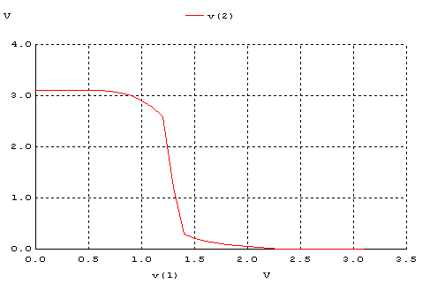
Volt | VOH | VOL | VIH | VIL | VM | NMH | NML
A | 3.10 | 0.11 | 1.40 | 0.85 | 1.25 | 1.70 | 0.74
B | 3.10 | 0.32 | 2.00 | 1.60 | 1.85 | 1.10 | 1.28
C | 2.80 | 0 | 2.25 | 1.10 | 1.50 | 0.55 | 1.10
D | 3.10 | 0 | 1.42 | 1.10 | 1.30 | 1.68 | 1.10

2-a
Kod:
**Soru2a
.MODEL MOSN NMOS LEVEL=2 LD=0.15U TOX=200.0E-10
+ NSUB=5.36726E+15 VTO=0.743469 KP=8.00059E-05 GAMMA=0.543
+ PHI=0.6 U0=655.881 UEXP=0.157282 UCRIT=31443.8
+ DELTA=2.39824 VMAX=55260.9 XJ=0.25U LAMBDA=0.0367072
+ NFS=1E+12 NEFF=1.001 NSS=1E+11 TPG=1.0 RSH=70.00
+ CGDO=4.3E-10 CGSO=4.3E-10 CJ=0.0003 MJ=0.6585
+ CJSW=8.0E-10 MJSW=0.2402 PB=0.58
.MODEL MOSP PMOS LEVEL=2 LD=0.15U TOX=200.0E-10
+ NSUB=4.3318E+15 VTO=-0.738861 KP=2.70E-05 GAMMA=0.58
+ PHI=0.6 U0=261.977 UEXP=0.323932 UCRIT=65719.8
+ DELTA=1.79192 VMAX=25694 XJ=0.25U LAMBDA=0.0612279
+ NFS=1E+12 NEFF=1.001 NSS=1E+11 TPG=-1.0 RSH=120.6
+ CGDO=4.3E-10 CGSO=4.3E-10 CJ=0.0005 MJ=0.5052
+ CJSW=1.349E-10 MJSW=0.2417 PB=0.64
VDD 3 0 DC 3.1
VIN 1 0 PULSE(0 3.1 0 1ns 1ns 4ns 10ns)
M1 2 1 0 0 MOSN W=1.8u L=1.2u NRS=0.333 NRD=0.333
+ AD=6.5p PD=9.0u AS=6.5p PS=9.0u
R1 3 2 100K
C1 2 0 1F
.CONTROL
TRAN 0.1NS 20NS
PLOT V(2) V(1)
.ENDC
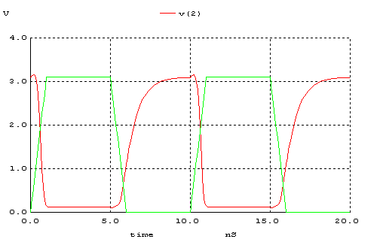
2-b
Kod:
**Soru2b
.MODEL MOSN NMOS LEVEL=2 LD=0.15U TOX=200.0E-10
+ NSUB=5.36726E+15 VTO=0.743469 KP=8.00059E-05 GAMMA=0.543
+ PHI=0.6 U0=655.881 UEXP=0.157282 UCRIT=31443.8
+ DELTA=2.39824 VMAX=55260.9 XJ=0.25U LAMBDA=0.0367072
+ NFS=1E+12 NEFF=1.001 NSS=1E+11 TPG=1.0 RSH=70.00
+ CGDO=4.3E-10 CGSO=4.3E-10 CJ=0.0003 MJ=0.6585
+ CJSW=8.0E-10 MJSW=0.2402 PB=0.58
.MODEL MOSP PMOS LEVEL=2 LD=0.15U TOX=200.0E-10
+ NSUB=4.3318E+15 VTO=-0.738861 KP=2.70E-05 GAMMA=0.58
+ PHI=0.6 U0=261.977 UEXP=0.323932 UCRIT=65719.8
+ DELTA=1.79192 VMAX=25694 XJ=0.25U LAMBDA=0.0612279
+ NFS=1E+12 NEFF=1.001 NSS=1E+11 TPG=-1.0 RSH=120.6
+ CGDO=4.3E-10 CGSO=4.3E-10 CJ=0.0005 MJ=0.5052
+ CJSW=1.349E-10 MJSW=0.2417 PB=0.64
VDD 3 0 DC 3.1
VIN 1 0 PULSE(0 3.1 0 1ns 1ns 4ns 10ns)
M1 2 1 0 0 MOSN W=1.8u L=1.2u NRS=0.333 NRD=0.333
+ AD=6.5p PD=9.0u AS=6.5p PS=9.0u
M1 2 0 3 3 MOSP W=1.8u L=1.2u NRS=0.333 NRD=0.333
+ AD=6.5p PD=9.0u AS=6.5p PS=9.0u
C1 2 0 1F
.CONTROL
TRAN 0.1NS 20NS
PLOT V(2) V(1)
.ENDC
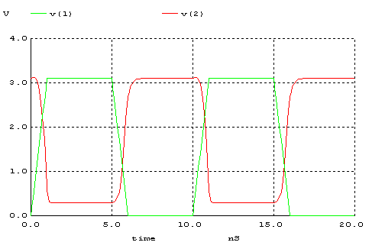

2-c
Kod:
**Soru2c
.MODEL MOSN NMOS LEVEL=2 LD=0.15U TOX=200.0E-10
+ NSUB=5.36726E+15 VTO=0.743469 KP=8.00059E-05 GAMMA=0.543
+ PHI=0.6 U0=655.881 UEXP=0.157282 UCRIT=31443.8
+ DELTA=2.39824 VMAX=55260.9 XJ=0.25U LAMBDA=0.0367072
+ NFS=1E+12 NEFF=1.001 NSS=1E+11 TPG=1.0 RSH=70.00
+ CGDO=4.3E-10 CGSO=4.3E-10 CJ=0.0003 MJ=0.6585
+ CJSW=8.0E-10 MJSW=0.2402 PB=0.58
.MODEL MOSP PMOS LEVEL=2 LD=0.15U TOX=200.0E-10
+ NSUB=4.3318E+15 VTO=-0.738861 KP=2.70E-05 GAMMA=0.58
+ PHI=0.6 U0=261.977 UEXP=0.323932 UCRIT=65719.8
+ DELTA=1.79192 VMAX=25694 XJ=0.25U LAMBDA=0.0612279
+ NFS=1E+12 NEFF=1.001 NSS=1E+11 TPG=-1.0 RSH=120.6
+ CGDO=4.3E-10 CGSO=4.3E-10 CJ=0.0005 MJ=0.5052
+ CJSW=1.349E-10 MJSW=0.2417 PB=0.64
*M1 D G S B MOSP W=1.8u L=1.2u NRS=0.333 NRD=0.333
*+ AD=6.5p PD=9.0u AS=6.5p PS=9.0u
VDD 3 0 DC 3.1
VIN 1 0 PULSE(0 3.1 0 1ns 1ns 5ns 10ns)
M1 2 1 3 3 MOSP W=1.8u L=1.2u NRS=0.333 NRD=0.333
+ AD=6.5p PD=9.0u AS=6.5p PS=9.0u
R1 2 0 100K
C1 2 0 1F
.CONTROL
TRAN 0.1NS 20NS
PLOT V(2) V(1)
.ENDC

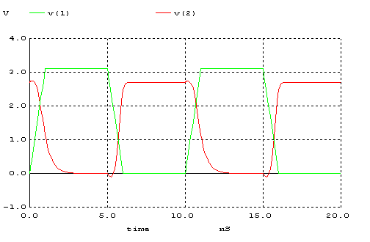
2-d
Kod:
**Soru2d
.MODEL MOSN NMOS LEVEL=2 LD=0.15U TOX=200.0E-10
+ NSUB=5.36726E+15 VTO=0.743469 KP=8.00059E-05 GAMMA=0.543
+ PHI=0.6 U0=655.881 UEXP=0.157282 UCRIT=31443.8
+ DELTA=2.39824 VMAX=55260.9 XJ=0.25U LAMBDA=0.0367072
+ NFS=1E+12 NEFF=1.001 NSS=1E+11 TPG=1.0 RSH=70.00
+ CGDO=4.3E-10 CGSO=4.3E-10 CJ=0.0003 MJ=0.6585
+ CJSW=8.0E-10 MJSW=0.2402 PB=0.58
.MODEL MOSP PMOS LEVEL=2 LD=0.15U TOX=200.0E-10
+ NSUB=4.3318E+15 VTO=-0.738861 KP=2.70E-05 GAMMA=0.58
+ PHI=0.6 U0=261.977 UEXP=0.323932 UCRIT=65719.8
+ DELTA=1.79192 VMAX=25694 XJ=0.25U LAMBDA=0.0612279
+ NFS=1E+12 NEFF=1.001 NSS=1E+11 TPG=-1.0 RSH=120.6
+ CGDO=4.3E-10 CGSO=4.3E-10 CJ=0.0005 MJ=0.5052
+ CJSW=1.349E-10 MJSW=0.2417 PB=0.64
VDD 3 0 DC 3.1
VIN 1 0 PULSE(0 3.1 0 1ns 1ns 4ns 10ns)
M1 2 1 0 0 MOSN W=1.8u L=1.2u NRS=0.333 NRD=0.333
+ AD=6.5p PD=9.0u AS=6.5p PS=9.0u
M1 2 1 3 3 MOSP W=1.8u L=1.2u NRS=0.333 NRD=0.333
+ AD=6.5p PD=9.0u AS=6.5p PS=9.0u
C1 2 0 1F
.CONTROL
TRAN 0.1NS 20NS
PLOT V(2) V(1)
.ENDC
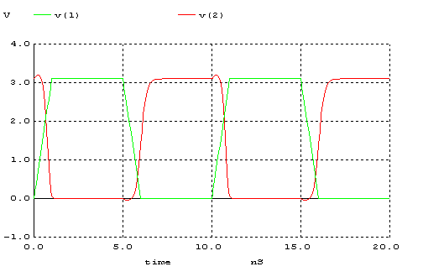

nS | tr | tf | tpLH | tpHL | td
A | 2.0 | 0.5 | 0.8 | 0.2 | 0.5
B | 0.6 | 0.3 | 0.2 | 0.3 | 0.25
C | 1.5 | 3.0 | 0.3 | 0.4 | 0.35
D | 0.3 | 0.2 | 0.4 | 0.2 | 0.3

3.
a) Tasarlanan bir devrenin iyi bir tersleyici olmasını istiyorsak; noise margin aralıklarının geniş ve simetrik (NMH=NML) olmasını isteriz. Ayrıca tanımsız bölgenin de mümkün olduğunca dar olmasını isteriz. Bu özellikler göz önünde tutulursa en iyi devre D şıkkında verilen devredir.
b) Şıklarda verilen devreler simetrik değildir. Zaman sabiti olan τ = RC göz önünde bulundurulursa; devrelerin simetrik olması için R ve C değerlerinin aynı olması gerekir.
Kullandığımız C değerleri her devrede aynı olduğuna göre, R değerlerini aynı yapmamız gerekir.Bunun için de NMOS ve PMOS transistörlerinin parazitik dirençlerinin ve devrelerde kullanılan diğer dirençlerin aynı olması gerekir.

4.
Kod:
**Soru4
.MODEL MOSN NMOS LEVEL=2 LD=0.15U TOX=200.0E-10
+ NSUB=5.36726E+15 VTO=0.743469 KP=8.00059E-05 GAMMA=0.543
+ PHI=0.6 U0=655.881 UEXP=0.157282 UCRIT=31443.8
+ DELTA=2.39824 VMAX=55260.9 XJ=0.25U LAMBDA=0.0367072
+ NFS=1E+12 NEFF=1.001 NSS=1E+11 TPG=1.0 RSH=70.00
+ CGDO=4.3E-10 CGSO=4.3E-10 CJ=0.0003 MJ=0.6585
+ CJSW=8.0E-10 MJSW=0.2402 PB=0.58
.MODEL MOSP PMOS LEVEL=2 LD=0.15U TOX=200.0E-10
+ NSUB=4.3318E+15 VTO=-0.738861 KP=2.70E-05 GAMMA=0.58
+ PHI=0.6 U0=261.977 UEXP=0.323932 UCRIT=65719.8
+ DELTA=1.79192 VMAX=25694 XJ=0.25U LAMBDA=0.0612279
+ NFS=1E+12 NEFF=1.001 NSS=1E+11 TPG=-1.0 RSH=120.6
+ CGDO=4.3E-10 CGSO=4.3E-10 CJ=0.0005 MJ=0.5052
+ CJSW=1.349E-10 MJSW=0.2417 PB=0.64
VDD 3 0 DC 3.1
VIN 1 0 PULSE(0 3.1 0 1ns 1ns 5ns 10ns)
M1 2 1 0 0 MOSN W=1.8u L=1.2u NRS=0.333 NRD=0.333
+ AD=6.5p PD=9.0u AS=6.5p PS=9.0u
M1 2 1 3 3 MOSP W=5.4u L=1.2u NRS=0.111 NRD=0.111
+ AD=16.2p PD=11.4u AS=16.2p PS=11.4u
C1 2 0 1F
.CONTROL
DC VIN 0 3.1 0.1
PLOT V(2) VS V(1)
.ENDC
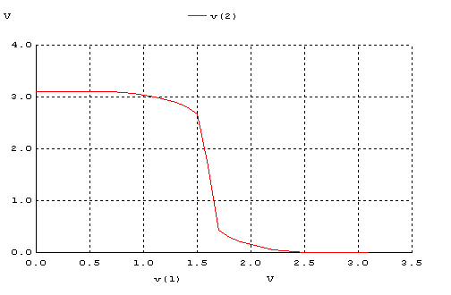

Bir MOSFETin W/L oranını artırırsak mosfetin direnç değeri azalır.Bundan dolayı da zaman sabiti küçülür ve Vm değeri yukarı kayar.1. sorunun d şıkkındaki devrede PMOS direnç değerini buna göre değiştirdik.Sonuç olarak Vm=1.30 iken Vm=1.65 olmuştur.

